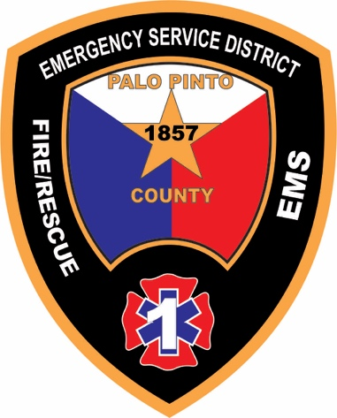

MINUTES OF SPECIAL CALLED MEETING
PALO PINTO COUNTY EMERGENCY SERVICES DISTRICT No.1
March 4, 2026

STATE OF TEXAS
COUNTY OF PALO PINTO

The Board of Commissioners (“Board”) of the Palo Pinto County Emergency Services District No.1 (“ESD” and/or “District”) met in a special called meeting open to the public on March 4, 2026, at 4:38 p.m. at the ESD administrative building located at 55 South FM 2353 Graford, Texas 76449, pursuant to a notice (“Notice”) duly given in accordance with law. A true and correct copy of the Notice is attached to these Minutes.

General Matters
- Call to order and establish quorum.
Commissioner Potter confirmed that each Commissioner comprising the ESD Board (i) had received notice of the time, place, and purpose of the meeting, and (ii) was present in person as follows:
Commissioner | Position | In Attendance
Brad Potter | President | Yes
Rodney Hall | Vice President | Yes
Mike Carter | Secretary | Yes
Casey McGlaun | Treasurer | No
Bridgett Worley | Assistant Treasurer | Yes
He stated that a quorum of the Board existed and called the meeting to order. He confirmed that each Commissioner present had received the meeting materials in advance of the meeting and directed Commissioner Carter, as Secretary of the Board, to file a copy of those materials with the minutes of the meeting.
ESD Fire Chief Danny Watkins, Assistant Fire Chief Kent Farquhar and District Administrator Mistie Garland-Clasby were present in person along with Amy Bearden and several fire department service provider representatives and other citizens.
- Public comments and announcements.
There were no public comments or announcements.
New Business
- Conduct a workshop to discuss/consider/take action on strategic and operational planning; ad valorem and sales tax budgets for calendar year January 1, 2026 to December 31, 2026, including any amendments thereof; and 2027-2028 Agency Agreements for fire department service providers to the ESD.
Commissioner Potter guided the Board and attendees through discussions regarding the following: status of the District’s purchase agreement for five (5) fire apparatus water tenders from First in Public Safety Solutions; draft dispatch standard operating procedures for first responder response; strategic and tactical communications plan for 2026; property and casualty insurance for fire department service provider vehicles and real property; and proposed economic and other changes to the District’s 2027-2028 Agency Agreements for fire department service providers to the ESD.

The Board and attendees discussed these matters. At the conclusion of the discussions on the matters, the Board (i) conceptually agreed on recommendations for certain of the matters discussed, and (ii) directed that those recommendations, including their estimated costs and expenses, be at the next regular meeting(s) of the Board for further discussion and consideration for action.

Other Business
- Adjourn.
At 6:20 p.m. Commissioner Hall made a motion to adjourn the meeting. Commissioner Worley seconded the motion. No discussion. The motion passed 4 ayes / 0 nays.

The above minutes for the special called meeting of the Board of the Palo Pinto County Emergency Services District No.1 held on March 4, 2026 were approved at the March 18, 2026 regular meeting of the ESD Board.

______________________________
Mike Carter, Secretary

